ACKNOWLEDGEMENT

We have found this rare opportunity to evince a word of thanks to all those who played a key role in the successful completion of our project. We sincerely thank our Head of Department Parth Shah Sir for giving the chance as well as support for all the time being. And his able guidance and continuous encouragement made us work in all the challenges during project development. We express deep gratitude to Prof. Jalpesh Vasa,Prof. Mrudang Pandya assistant professor and internal project guide from Faculty of Engineering, CHARUSAT for their valuable suggestions, help and moral support. Finally, most of all, we thank our family members for their unconditional love, encouragement and support to complete our project work. We also thank to all those who could not find a separate name but have helped directly and indirectly.

Meet Shah(16IT124)
Priyank Raval(16IT107)
Abhi Savadiyawala (16IT114)

Abstract

This application is useful to do VideoCall in Intranet without setup client and server. It’s had hybrid architecture. It’s work on only for same Network. Suddenly if you are in collage or some huge area of company who has in intranet between their different Department, Internet is goes down and their pc connected in same Network this application is useful to do VideoCall or Text Chat.

INDEX

Serial number | Chapter | Page number
1 | Project definition……………………………… | 6
2 | Objective…………………………………….... | 7
3 | Software and hardware requirement………….. | 8
4 | Screenshots of the project output……………... | 9
5 | Limitations……………………………………. | 10
6 | Outcome………………………………………. | 11
7 | Future enhancement…………………………... | 12
8 | References…………………………………….. | 13

Chapter 1: Project Definition

- This project is user for communication of videocall or textchat.
- Project is an application to do VideoCall in same network and no needed to setup requirement of any server.
- Project is based on Desktop application, portable version and easy to use (more user friendly) for communication of two people.

Chapter 2: Objectives

- First appear Welcome screen.If user

- User has to insert friend’s IP and click on Start

- VideoCall: User send his IP to the friend and friend has to insert that ip in his application and press start button. After press start button start VideoCall.

- TextChat: For TextChat User and his friend also insert port no.

Chapter 3: Software and Hardware Requirements

- Software Requirements: Browser(Chrome, Mozilla,Opera.etc.)
Visual Studio

s
- Hardware Requirements: 512 MHZ or more processor
512 MB RAM

Chapter 4: Screenshots of project output

- Output:

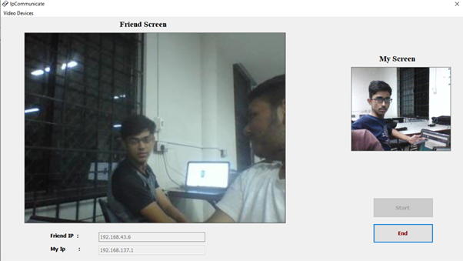

]

- TextChat

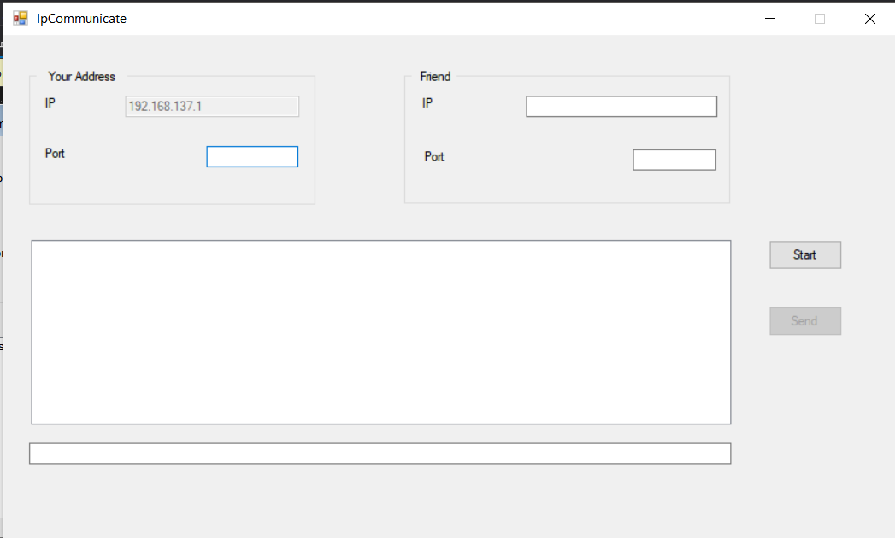

- When Connection Lose
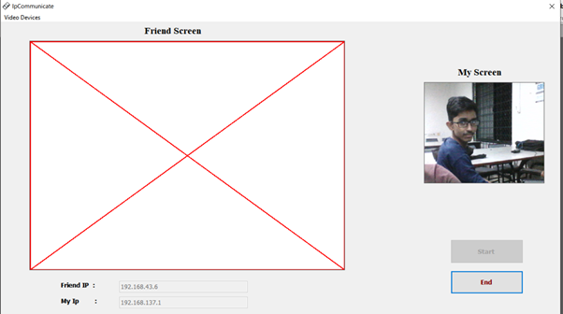

Chapter 5: Limitations of project

- It is not use in Different Network.
- It has Not Voice .
- If os not given assecs to use camera,application can not useful.
- User has to give permission to assecs firewall.

Chapter 6: Outcome

- From this project we can do videocall to our friend who can connected in same network but at other place.

- From this project we can do videocall easily without any type of server

- From TextChat We can do textchat with friend.

Chapter 7: Future Enhancement

- Project should be extended in such a way that after submitting your required things your data should have been seen by user and all the other people.

- Project shoul be extended in such a way that it can use easily and also add voice in videocall.

- We can also add groupcall and voicecall in this Project.

- We can upgrade textchat and make more userfriendly.

Chapter 8: References

- http://www.socketcoder.com/
- https://docs.microsoft.com/en-us/dotnet/api/system.net.sockets.socket?view=netframework-4.7.2
- https://www.guru99.com

